Washington Child Passenger Safety Network 1-8-26
REGION 1  Clallam/Jefferson  TZM – Josh Ley  360-417-2273  joshua.ley@clallamcountywa.gov  *CPS – Emily Rosado  360-775-4379  emilyrrosado@gmail.com  REGION 2  Grays Harbor/Mason/Pacific  *TZM – Haley Falley  360-500-4351  Haley.Falley@graysharbor.us  REGION 3  Cowlitz/Lewis/Wahkiakum  *TZM – Rochelle Nugent  360-577-3041  rnugent@cwcog.org  Cowlitz/Wahkiakum  SK – Brianna Harvill  360-270-2723  safekidslc@gmail.com  Cowlitz/Wahkiakum  *CPS - Brandi Ballinger  360-575-6280  Brandi.ballinger@c2fr.org  REGION 4  Thurston  TZM – VACANT  *SK – Danielle King  360-522-3108  danielle.king@ccacwa.org | REGION 5  Pierce  *TZM – Donna Kelly  253-453-0261  Dkelly3@cityoftacoma.org  tzmregion5@outlook.com  REGION 6  Clark/Skamania  TZM – Jesamie Peters  503.341.8896  TZMJesamie@outlook.com  *SK – Weston Perkins-Clark  564-208-4272  Weston.Perkins-Clark@gmr.net  REGION 7/8  King  North  TZM – Rebecca Lis  206-477-5085  rlis@kingcounty.gov  North  TZM – Gurman Kaur  206-477-5085  gkaur@kingcounty.gov  South  TZM – Sara Hallstead  253-856-5856  swood@kentwa.gov  SK – Fran Kwak  206-744-4967  fkwak@uw.edu  *CPS – Laura Miccile  253-653-7514  miccile@msn.com  REGION 9  Kitsap  TZM – Amy Grimsley  360-633-0805  agrimsley@kitsap.gov  *SK – Allison Degracia  allison.degracia@kitsappublichealth.org | REGION 10  Snohomish  TZM – Stacey McShane  425-388-3817  Stacey,McShane@snoco.org  *SK – Shawneri Guzman  425-551-1254  sguzman@southsnofire.org  REGION 11  Whatcom/Skagit/San Juan/Island  TZM – Carr Lanham  360-815-4243  CLanham.wtsc@outlook.com  *CPS – Erica Littlewood  360-220-2994  elittlewood@swrfa.org  REGION 12  Chelan/Douglas/Kittitas/ Okanogan  *TZM - Rachael Stiver  rachael@chelan-douglas.org  509-663-9059  Eveline Roy  509-888-4205 / 509-670-8914  er.roy@frontier.com  Okanogan  CPS – Laurie Jones  509-422-7158  ljones@co.okanogan.wa.us  Kittitas  CPS – Audelia Y. Martinez  509.933.8228  audelia.martinez@co.kittitas.wa.us  REGION 13  Yakima/Klickitat  TZM – Maria Lopez  509-759-7996  *CPS – Nichole Sandino  509-576-6517  Nichole.sandino@yakimawa.gov | REGION 14  Benton/Franklin  TZM – Jen Dorsett  509-851-1348  jdorsett14@outlook.com  *SK – Ben Thomos  509-460-4214  ben.thomas@bfhd.wa.gov  REGION 15  Grant/Adams/Lincoln/  Ferry  *TZM – VACANT  Interim: mvargas@granthealth.org  REGION 16  Spokane/Stevens/Pend Oreille/Whitman  TZM – John Griffin  509-477-2342  JGriffin@spokanecounty.org  *SK / CPS - Renee Witmer  (509)844-1854  renee.witmer@providence.org  Whitman only  *SK Inland – Meghan Johns  meghan.johns@whitmancounty.net  REGION 17  Walla Walla/Columbia/  Garfield/Asotin  TZM – Melanie Owens  509-524-2667  mowens@co.walla-walla.wa.us  *SK – Debi Allessio  509-529-2130  debiallessio@icloud.com
*Distributes statewide announcements | TZM – Target Zero Manager | SK – Safe Kids Coalition | CPS – Child Passenger Safety Lead
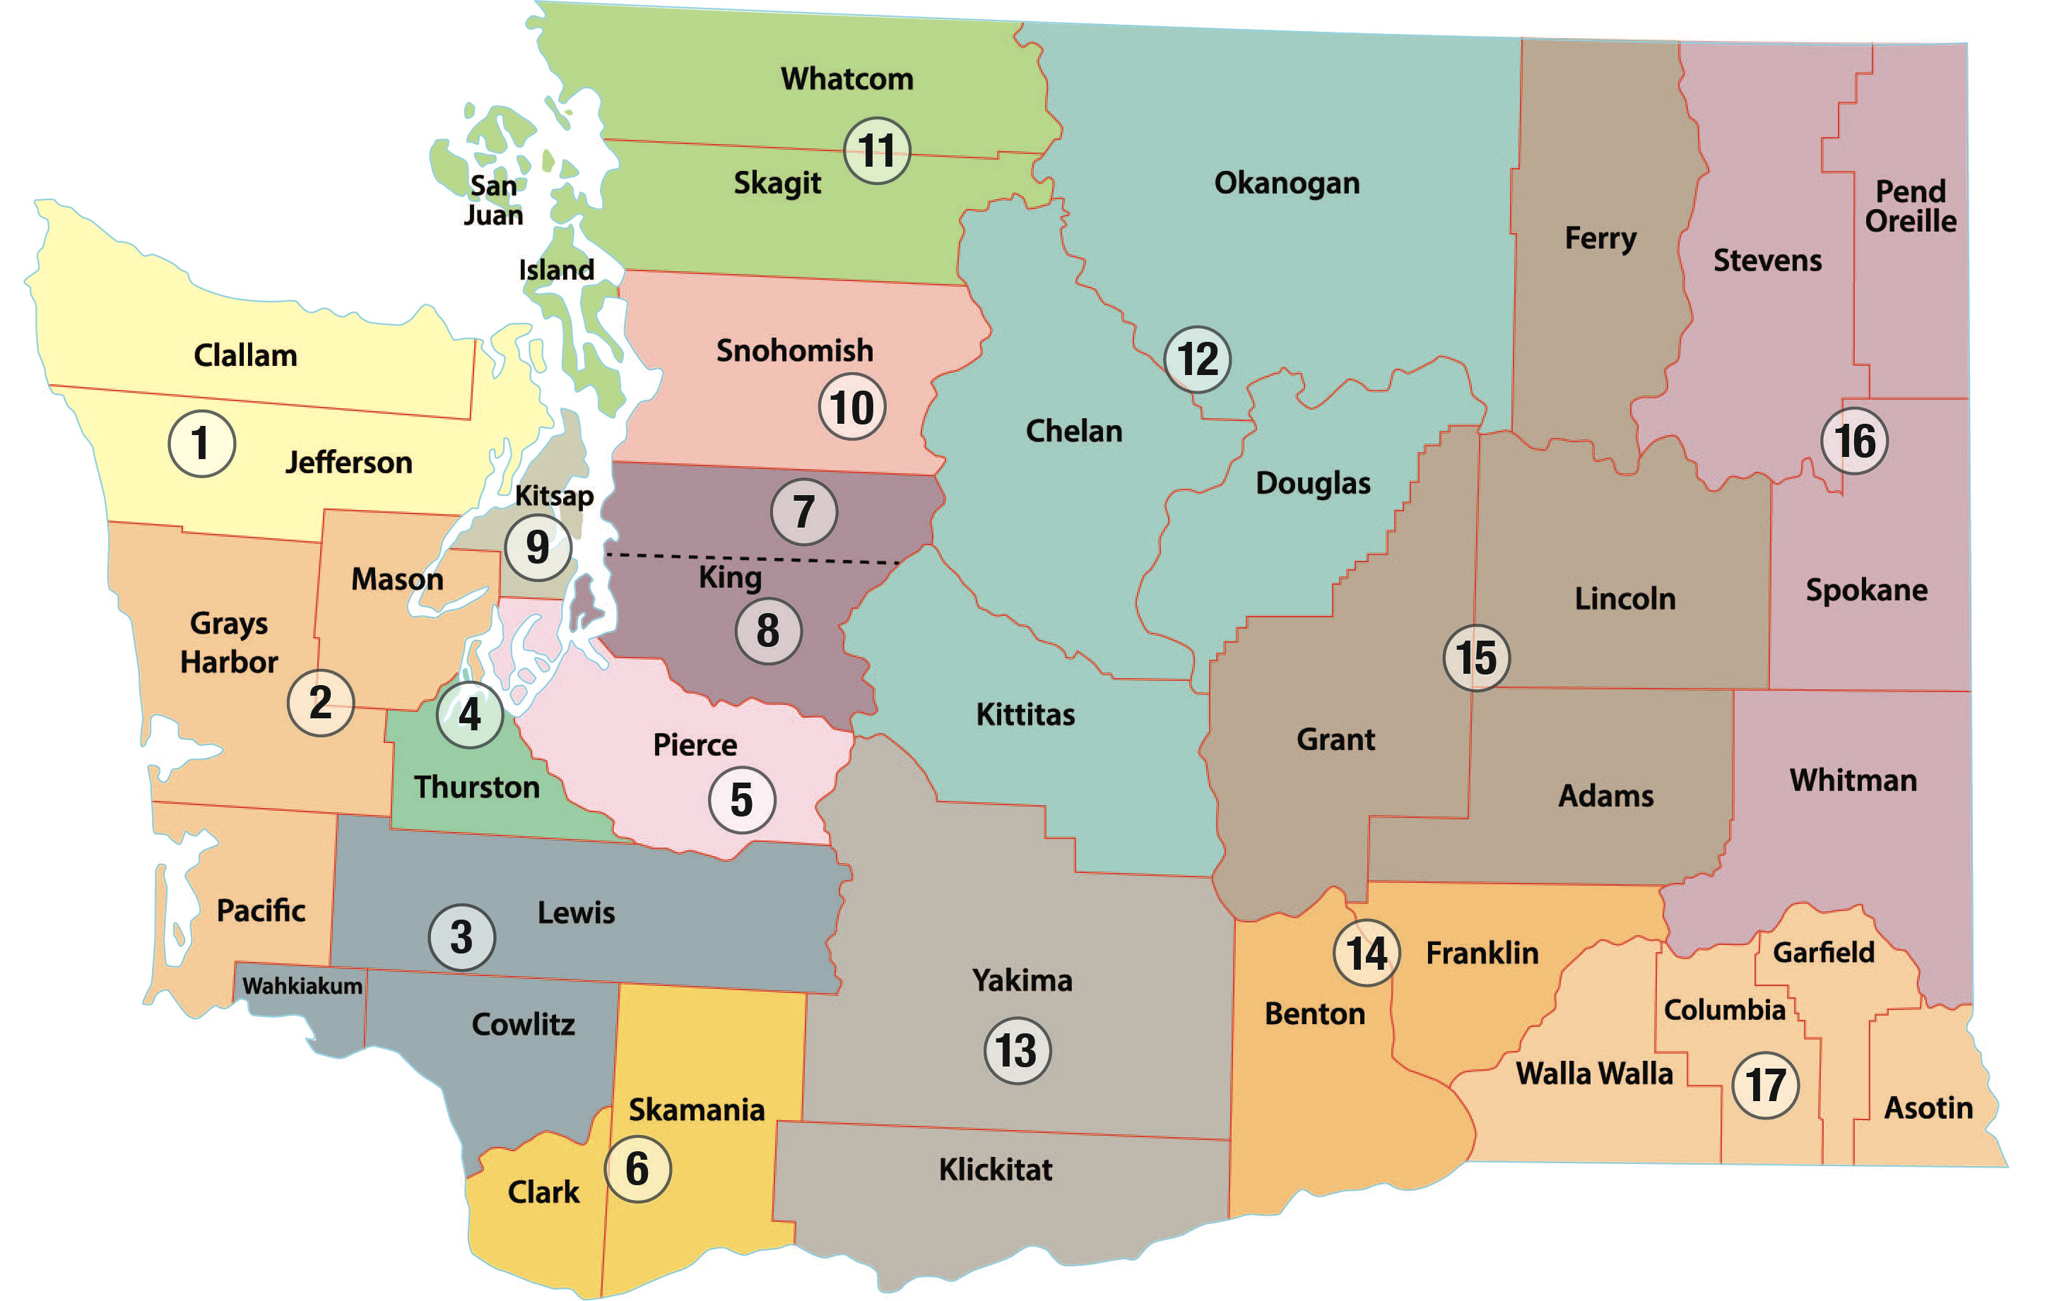
Mandie (1, 2, 3, 4, 6, 9)
Jerry (5, 7, 8, 10, 11)
Mark (12, 13, 14, 15, 16, 17)

