PROCESS FOR CHILD RESTRAINT TRAINING
In order to teach the Car Seat Awareness Class, the technician must follow the acquisition process to obtain the state approved curriculum. https://wacarseats.com/car-seat-awareness-for-child-transporters/

STEP 1: CHILD RESTRAINTS

Staff meets with technician(s) to inventory current child restraints. Usually conducted on a Saturday when there is the most access to the vehicles and child restraints. Spreadsheet is provided for inventory of seats.
Each seat is checked for missing parts, harness route/twists, recalls, etc.

FOLLOW-UP ACTIONS:
Technician/Host Agency
Defective/expired/recalled seats taken out of inventory for destruction.
Technician
Provides copy of inventory sheet.
Host Agency
Ensures access to educational material is readily available for transporters.

Tools needed:
- Clip board with tracking sheet
- Scissors
- Phillips screwdriver
- Graco booster seat screws
- Post its
- Gloves
- Sharpie

STEP 2: VEHICLES

Host Agency provides technician with list of vehicles used for transport which includes information on spreadsheet provided for vehicle inventory.

FOLLOW-UP ACTIONS:
Technician
Uses examples from agency vehicles during Car Seat Awareness Class. Notes any unusual locations of top tether anchor, lower anchors, etc. Review the vehicle manual before class.
Host Agency
Ensures each vehicle has owner’s manual.
Earmarks the “child safety, child restraints” section in the vehicle manual OR
places a print-out of section in vehicle binder.
Educational materials provided in each vehicle.

STEP 3: EDUCATION

Technician:
Needs use of projector, screen, laptop (who is providing?).
Brings training seat and dolls.
Handouts for attendees.
Provides “Letter of Completion” if requested from DCYF.
Students complete pre-class and post-class surveys.
Host Agency:
Schedules two-hour Car Seat Awareness Class with technician/instructor.
Promotes class with staff.
Reserves 2-3 vehicles for availability the day of class. These will be used for hands-on practice.
Provides availability to various child restraints.
Provides sign-in sheet for class (optional).
Prints “Letters of Completion” for each attendee (optional).

Tools needed:
- Projector, screen, laptop, curriculum
- HDMI and USB cables
- Extension cord
    - Sign in sheet
    - Training seat
    - Dolls
    - Take home educational material
    - Letter of Completion

FOLLOW-UP ACTIONS:
Technician:
Encourages a yearly in-person class held for transporters.
Shares virtual Car Seat Awareness to provide between classes for new-hires.
https://www.southsnofire.org/community-programs/classes/car-seats

SUGGESTED ADDITIONAL STEPS:
Host Agency:
Develop written procedure for seat selection, check-out, and return.

When purchasing seats for child transport, consider selecting those with the least amount of steps for harness adjustment and installation (no rethread harness seats) . Feel free to consult your Car Seat Awareness instructor prior to purchase.

Provide easy/quick access to car seat manufacturer list for obtaining instructions for use and installation.

Arrange the opportunity for child transporters to attend a Car Seat Awareness Class every 1-2 years. This is necessary due to changes in the law, child restraints, motor vehicles, and recommendations from safety expects like American Academy of Pediatrics.

PRE-CLASS QUESTIONS

Thank you for your interest in learning how to safely transport children. Please answer the following questions. Answer according to your current knowledge (without researching answers).

- What makes you interested in attending this class?

- What best describes your role in transporting children
- Parent or caregiver
- Childcare Provider
- Contracted Transporter
- Volunteer/Other_____________________

- How did you hear about the class?

- When a child is in a rear-facing car seat, where should the harness straps be located on the shoulders?
- Slightly above the shoulders
- At or below the shoulders
- At or above the shoulders

- When a child is in a forward-facing car seat, where should the harness straps be located on the shoulders?
- Slightly above the shoulders
- At or below the shoulders
- At or above the shoulders

- According to Washington State Law, at what age can a child legally ride in the front seat, when practical?
- 12 years old
- 13 years old
- Age doesn’t matter

POST-CLASS QUESTIONS

Thank you for attending today’s class. Please answer the following.

- When installing a car seat you should (select all that apply):
- Read and follow the car seat manufacturer’s instructions
- Ask for recommendations on Facebook
- Read and follow your vehicle’s owner’s manual instructions
- Email a friend for advice

- According to Washington State Law, at what age can a child legally ride in the front seat, when practical?
- 13 years old
- Age doesn’t matter; it’s the size of the child
- 12 years old

- When a child is riding rear-facing, where should the harness straps be located on the shoulders?
- Slightly above the shoulders
- At or below the shoulders
- At or above the shoulders

- When a child is riding forward-facing, where should the harness straps be located on the shoulders?
- At or below the shoulders
- At or above the shoulders
- Slightly above the shoulders

- I lost my car seat manufacturer’s instructions. Now what?
- Go to the car seat manufacturer’s website and download a copy.
- Ask a friend if they have a copy.
- Rely only on the labels of the car seat.
- Wing it!

- On a scale of 1 – 5 how useful was the information you learned today?
Not at all 1 ---------- 2 ---------- 3 ---------- 4 ---------- 5 Extremely

- On a scale of 1 – 5 how confident do you feel in your ability to correctly use your car seat?
Not at all 1 ---------- 2 ---------- 3 ---------- 4 ---------- 5 Extremely

- Would you recommend this class to others? (circle answer)
Yes No
- Feel free to offer any other feedback.

DCYF SEAT INVENTORY RECOMMENDATIONS
For the purpose of emergency transport of children by support agencies, a NO RE-THREAD harness seat is recommended. The style allows quick adjustment of harness system to child’s weight and height.
It is also encouraged the various DCYF sites purchase the same style seats so adjustment, installation, and training is consistent. Below are some examples of no re-thread harness seats.

REAR-FACING ONLY SEATS
Graco SnugRide SnugLock 35 Elite Infant Car Seat, Oakley Gray - Walmart.com

Amazon.com: Graco SnugFit 35 Infant Car Seat | Baby Car Seat with Anti Rebound Bar, Gotham : Everything Else

CONVERTIBLE SEATS
Evenflo Revolve360 Rotational All-In-One Convertible Car Seat, Amherst Gray - Walmart.com

Amazon.com: Graco Contender Slim Convertible Car Seat, West Point : Everything Else

Graco Extend2Fit® Convertible Car Seat | Graco Baby

BOOSTER SEATS
If all vehicles have headrests, backless boosters may be used.

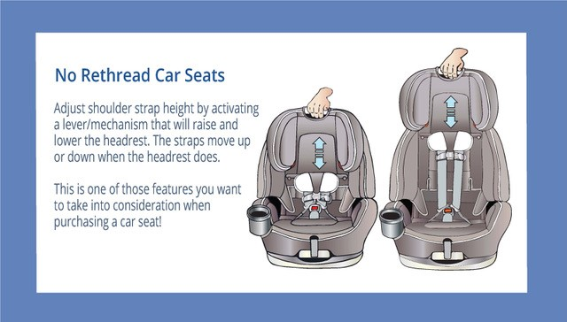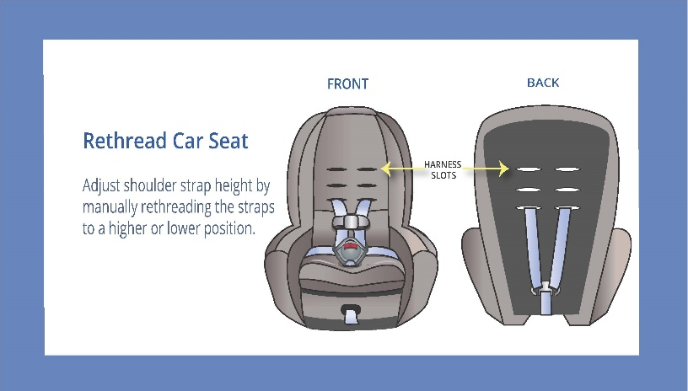

Car Seat Manufacturer Websites:

BABY JOGGER: www.babyjogger.com
BABY TREND: www.babytrend.com
BRITAX & BOB: www.us.britax.com
CHICCO: www.chiccousa.com
CLEK: www.clekinc.com
COMBI: www.combiusa.com
COSCO: www.coscokids.com
DIONO: www.diono.com
EVENFLO: www.evenflo.com
GRACO: www.gracobaby.com
MAXI-COSI: www.maxicosi.com
NUNA: www.nunababy.com
PEG PEREGO: www.pegperego.com
SAFETY 1ST: www.safety1st.com
UPPAbaby: www.uppababy.com

