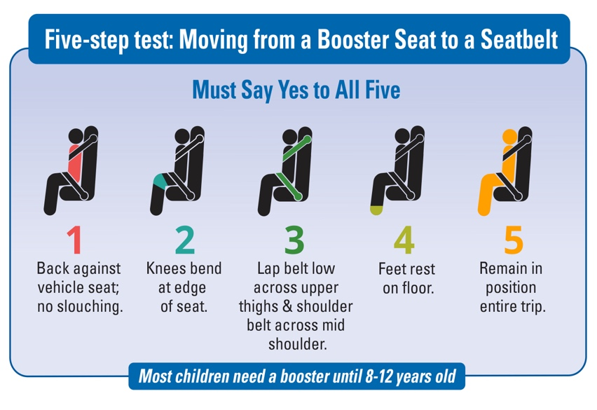For more information, visit www.wacarseats.com Be sure your child ride safeBe sure Be sure your child ride safe on every trip.

**The Safest Ride**

**Is your child riding safely in the car?**

**Be sure kids under age 13 ride in the back seat and in booster seats until 4’9” tall.**

**It’s the law (RCW 46.61.687).**

**Your school recently partnered with local Child Passenger Safety Technicians to help protect your child from serious injury and death in a car crash.**

**Observational surveys were conducted before and after the education and awareness campaign.**

**Be sure your child’s ride is safe on every trip.**

**Everyone is Safer in the Back Seat-Especially Kids!**

Kids under the age of 13 riding in the front seat are 50% more likely to be killed or seriously injured in a vehicle crash than those riding in the back seat.

**It’s What’s on the Inside That Counts!**

It’s not about the size and weight, it’s about bone strength and body structure. Until age 13, kids’ bodies aren’t strong enough to withstand crash forces in the front seat.

**Boosters Provide Proper Placement of the Seat Belt!**

Studies show that using a booster seat can reduce risk of injury in a crash by 45 percent over a seat belt alone.

**It’s the law!** (RCW 461.61.687)

* 0 – 2 years = rear-facing car seat
* 2 – 4 years = car seat with harness
* 4 years and older = booster until 4’9” tall
* Up to age 13, ride in back seat