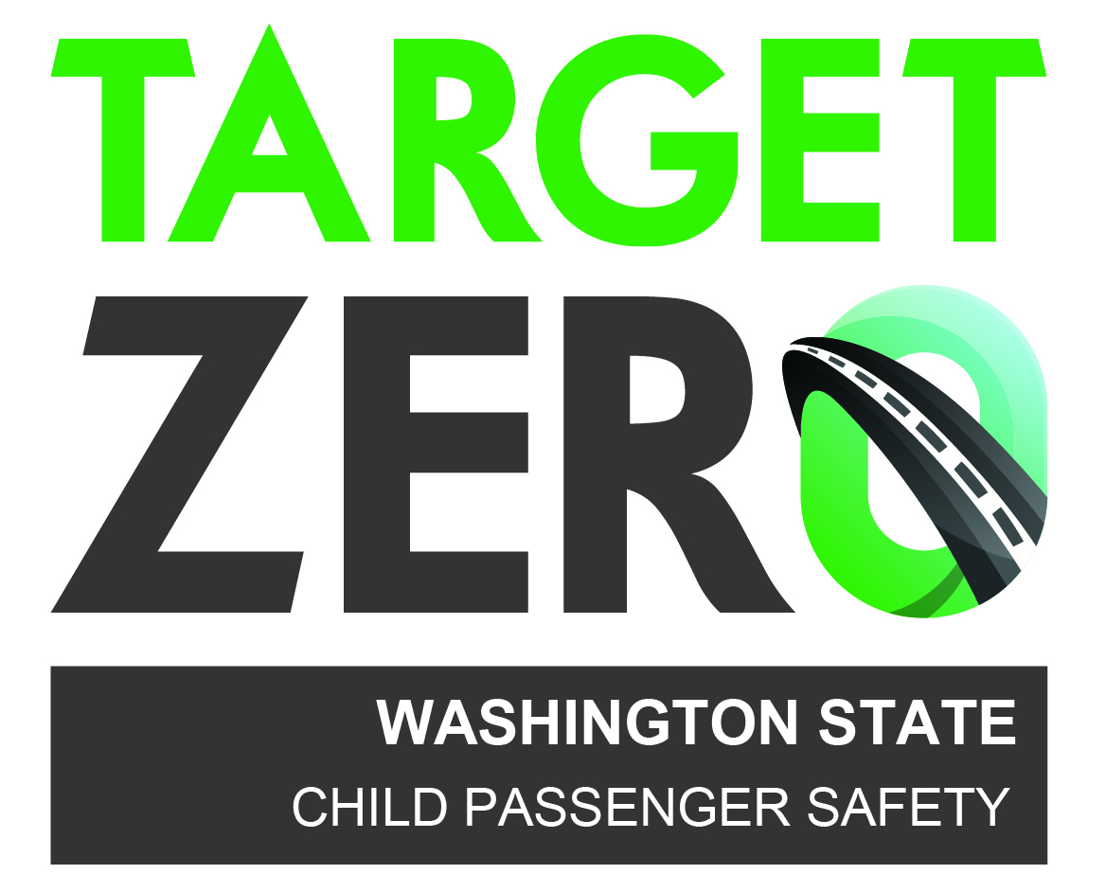
Requirements for services
funded by
Washington’s Child Passenger Safety Program

Each recipient certifies that the Child Passenger Safety grant will not be used to replace existing state or local funds, defined as supplanting. Compensation is not allowed for services covered by the Staff persons’ employer.

- Pre-approval through the grant process prior to start is required for all classes/services.
- Lodging, mileage, meals for Service Providers may be covered at state per diem rate IF prior approval is provided in grant or by Project Manager.
- Service Providers use invoice templates provided by the Project Manager when billing for services.

cpst certification Course

SCOPE OF SERVICES
Provide training to child passenger safety technician candidates utilizing NHTSA’s National Standardized Child Passenger Safety Technician (CPST) Certification Course. This course is typically a four day course which combines classroom instruction, hands-on work with child restraints and in vehicles, and real world car seat inspections. The hybrid CPST course is also acceptable.

Lead Instructor: responsible for every aspect of the course, including making sure the rosters are accurate and the course profile includes all members of the teaching team, entering participant scores, and calculating and entering instructor teaching hours when the course is over.

Assistant Instructor: perform responsibilities as designated by the Lead Instructor. Attend and participate in ALL planning meetings. Assist with classroom set-up/take down. Prepared to teach assigned modules.

Technician Assistant: perform responsibilities as designated by the Instructor Team. Attend and participate in planning meetings. Assist with classroom set-up/take down. Assist with indoor and outdoor exercises.

Instructor Candidate: meet standards of selection set forth in National CPS Certification Policies and Procedures. Complete daily evaluations and reviews with Mentor Instructor. Make every effort to improve teaching skills based on feedback provided. Perform responsibilities as designated by the Lead Instructor. Prepared to teach assigned modules and familiarity with curricula; includes prepping teaching aids such as child restraints, non-regulated products, handouts, etc.

Mentor Instructor: complete daily evaluations and reviews with Instructor Candidate. Primary contact for any questions or concerns about the Instructor Candidate evaluations. Makes every effort to help Instructor Candidate improve his/her skills.

TO RECEIVE STATE FUNDING
The CPST course must:
- Have a minimum of 5 participants
- Obtain a 1:5 ratio of instructor/participants (all other roles are optional)
- Invoice showing successful completion of scope of services
- Class and instructor evaluations turned into State’s Project Manager

compensation CRITERIA
Class with 5-10 participants = $3,900.00 maximum service fee amount (combined) for entire CPST Certification Instructor Team

Class with 11 to 15 participants = $5,400.00 maximum service fee amount (combined) for entire CPST Certification Instructor Team

      - Individual Instructor’s compensation can NOT exceed $2,400.00 (before travel)
- CPST Lead Instructor’s responsibility to reach consensus with service fee amounts for all CPST Certification Course Instructor Team.

NOTE: The lead instructor service fee is not AUTOMATICALLY $2,400.00. It can, and should, be adjusted among the other CPST Instructors according to time invested in the course. Items to consider: who assisted in hauling the vehicle training seats? who brought the assortment of child restraints? who taught the most modules? who will be available during the entire course? who will be helping with set-up/take-down of classroom?

CONTINUING EDUCATION UNITS (ceu’S)

SCOPE OF SERVICES
Provide nationally certified child passenger safety technicians the opportunity to earn continuing education units required for the bi-annual national recertification process. The responsibilities of the CEU presenter include the generation and/or preparation of the curriculum; obtaining pre-approval by SafeKids Worldwide with event number; helping to coordinate promotion, registration, size and location; generation of agenda, sign-in sheet; and providing authorized signature for recertification process.

TO RECEIVE STATE FUNDING
- Invoice showing successful completion of scope of services
- Class and instructor evaluations turned in to State’s Project Manager

compensation CRITERIA
1 CEU class for $200 3 CEU class for $400 5 CEU class for $600
2 CEU class for $300 4 CEU class for $500 6 CEU class for $700

car seat sign-offs

SCOPE OF SERVICES
Provide nationally certified child passenger safety technicians the opportunity to acquire the five identified seat inspections required for the bi-annual national recertification process. Seat sign-offs must be observed by a CPST Instructor or Technician Proxy. Instructor/Tech Proxy provides oversight and observes car seat technician as they assist family with car seat check; listens to education provided to caregiver; observes knowledge of technician; evaluates interaction between technician and caregiver; provides online approval for recertification process if technician is successful; and provides feedback and discusses other resources for obtaining sign-offs if technician fails or doesn’t complete all required seats.

TO RECEIVE STATE FUNDING
- Invoice showing successful completion of scope of services
- Seat sign-off evaluations turned into State’s Project Manager

compensation CRITERIA
2 hour car seat event $200 3 hour car seat event $300 4 hour car seat event $400

car seat awareness class

SCOPE OF SERVICES
The curriculum provides a comprehensive look at car seat safety. Attendees receive basic instruction and awareness about car seats, information about Washington State law, best practice and answers to frequently asked questions. The class is geared towards Public Health, DSHS transporters, foster parents, WIC, parents, caregivers, grandparents, social work, Child Protective Services, daycare, preschool, medical professionals, teachers, EMS, fire, police, nurses, pediatricians & other child transporters. This class is also used as an effective pre-screening tool for those expressing interest in obtaining child passenger safety technician certification. Providing hands-on opportunities for attendees is strongly encouraged.

TO RECEIVE STATE FUNDING
- Presenter (a certified child passenger safety technician) has obtained and utilizes the state approved curriculum after completing the Train-the-Trainer.
- Invoice showing successful completion of scope of services
- Class and instructor evaluations turned into State’s Project Manager

compensation CRITERIA
2 hour class for $200 4 hour class for $400 6 hour class for $600
3 hour class for $300 5 hour class for $500

CPST RENEWAL COURSE

SCOPE OF SERVICES
This class is designed to renew the certification for expired technicians who have stayed involved in CPS programs and activities and have monitored changes in the field by reading technical updates, attending other CPS classes, and working with non-expired technicians. It is an 8 hour class using the Certification Renewal Testing Course curriculum. CPST Instructor verifies technical skills through hands-on testing, and assesses CPS knowledge through an on-site written test.

TO RECEIVE STATE FUNDING
- Have a minimum of three participants
- Invoice showing successful completion of scope of services
- Class and instructor evaluations turned into State’s Project Manager

compensation CRITERIA
Lead Instructor up to $800
Assistant Instructor up to $500 (more than five participants in the class)

Technician proxy testimonials

SCOPE OF SERVICES
A Technician proxy can review and approve seat checks for recertification. This role helps bridge the gap in parts of the State where there are few certified instructors. Two signed testimonials are required; one certified instructor and a technician or second instructor. CPST Instructor observes technician conduct at least three real (not mock) seat checks with caregivers and at least 2 seat checks working with other Technicians as a senior/final checker. Observations are used to evaluate readiness and ability to (1) provide suitable and appropriate feedback and (2) pass and fail seat checks appropriately.

TO RECEIVE STATE FUNDING
- Invoice showing successful completion of scope of services
- Class and instructor evaluations turned into State’s Project Manager

compensation CRITERIA
CPST Instructor/Technician will be compensated according to how long it took to complete required seat checks.
2 hour = $200 3 hour = $300 4 hour = $400

s.t.a.c. class

SCOPE OF SERVICES
"Safe Travel for All Children: Transporting Children with Special Health Care Needs"
The training, which lasts two days, combines classroom lectures and discussions with hands-on exercises. During the training, participants will be introduced to medical conditions that can impact restraint selection and have the opportunity to investigate and install specialized restraint systems. The training concludes with a proficiency exam that evaluates the student's ability to assess appropriate restraints and to demonstrate proper use and installation.
.

TO RECEIVE STATE FUNDING
- Invoice showing successful completion of scope of services
- Class and instructor evaluations turned into State’s Project Manager

compensation CRITERIA
Lead Instructor $1,200.00
Assistant Instructor $800.00

